Exploring the influence of sport and physical activity participation among transplant recipients: Implications for positive psychological growth?

Summary Report

Prepared by: Tanya Scarapicchia, 3rd year B.Sc. student
Research assistant: Bianca Segatto, M.A. student
Supervisor: Dr. Catherine Sabiston
Department of Kinesiology and Physical Education,
McGill University

Summary of Study
Engagement in sport and physical activity offers a multitude of benefits, including enhanced physical fitness, increased social support networks, elevated positive affective states, and the development of perceptions of competence and enjoyment. Given these benefits, there is a potential for the development of positive psychological growth through sport and physical activity. For these reasons, sport and exercise participation has been recommended as a way to enhance overall quality of life in various populations, including among individuals who have been diagnosed with chronic illness, disease, or physical/psychological disability.

Based primarily on anecdotal evidence, one population that appears to be thriving from sport and physical activity participation is transplant recipients. Unfortunately, there has been limited empirical research focused on understanding how sport and physical activity impacts physical and mental health among transplant recipients. This is an important target population, since transplantation is associated with psychological distress and anxiety that can impede psychosocial functioning. However, there is evidence to suggest stress and coping strategies, social support and general emotional experiences may lead to positive psychological outcomes associated with transplant. While these functional emotional health outcomes are desirable, many studies targeting transplant recipients, whether during or following surgery and treatment, tend to focus more on the detriments to quality of life and general stress – with less emphasis on the positive changes following adversity.

Purpose:
The purpose of the study was to examine the potential for positive psychological growth experiences in a population of transplant recipients involved in physical activity. The objectives include examining relationships among motivation, stress and challenges, self-perceptions, goal adjustment, and positive psychological growth as a test of the post-traumatic growth (PTG) model (see Figure A) with transplant recipients. Differences in these relationships by age, gender, and time-since-transplant will also be explored.
Figure A.
Experiences of cancer
Social support
Increased network
Sharing information about BC
Understanding BC
Unconditional support
Opportunity to help
Unique from support groups
Coping with stress
Fun and laughter
Filling a void
Proving physical ability
Physical self-perceptions
Athletic identity
Competitiveness
More aerobically fit
Stronger
More physically competent
Positive psychological growth:
Closer relationships
New possibilities and opportunities
Psychological strength
Appreciation for life
Personal control
Persistent stressors and challenges
Constant reminders
Dealing with others’ illness and death
Visibility
Positive Psychological Growth Model (Sabiston, McDonough, & Crocker, 2007)

Significance:
This study seeks to understand a relatively understudied concept (positive psychological growth) in an under-represented population of transplant recipient sport participants. There is the potential to advance theoretical tenets, conceptual links, and practical intervention implications. This study will also provide foundational data to continue exploring the links between sport and physical activity and emotional experiences in clinical populations.

Describing the Sample:
This study included a total of 163 transplant recipients. The participants ranged in age from 20 to 76 years old with a mean age of 48.07 years. Of the respondents, 58.1% were males and 41.9% were females. The participants self-reported as Caucasian (n=136; 84%), Asian (n=7; 4.3%), Hispanic (n=2; 1.2%), First Nations or Aboriginal (n=2; 1.2%), Middle Eastern (n=2; 1.2%), South Asian (n=1; 0.6%), and Caribbean (n=1; 0.6%). Some participants (n=10; 6.9%) did not respond to this question. The first language of the participants was primarily English, consisting of 91.8% of the sample, 5.5% of the participants considered French as their first language.

Of the transplant recipients surveyed, 31.1% obtained an undergraduate degree and 13.5% received a post-graduate degree. The employment status of the respondents consisted of 54.7% of the sample being employed full time, 13.9% are employed part time and 31.4% are currently unemployed, this category also included the participants that are retired. Most of the participants were either married or living with their life partner (n=100, 68.8%), with the remaining transplant recipients identifying themselves as single (n=32, 22.4%), separated (n=3, 2.0%), and divorced (n=10, 6.8%).

There were a variety of transplantations reported (see Figure 1), including kidney (37.4%), liver (25.2%), heart (16.0%), lung (10.4%), bone marrow (5.5%), and either multiple organs or organ not specified (5.5%).

Figure 1. Percentage of Participants Reporting Type of Transplants Received
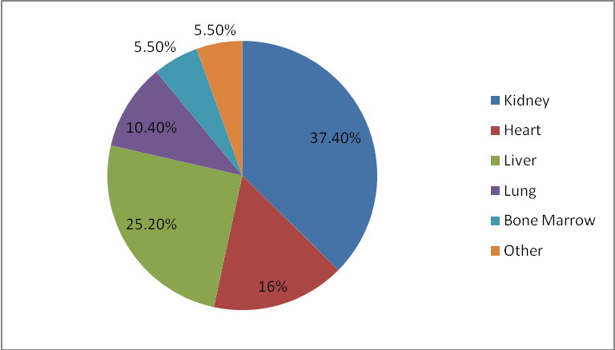
The participants were asked to rate the extent of distress that they experienced when they learned that they would need a transplant, ranging from 1=no distress to 7=a lot of distress. Figure 2 illustrates the responses to this question.

Figure 2. Percentage of Participants Reporting Each Degree of Emotional Distress Experienced

For the purpose of this summary report, we categorized this level of distress as those reporting little to no distress with scores of 1 through 4 (n=70) compared to participants who were distressed as a result of their transplant (n=75), with scores of 5 through 7.
The age at which the recipients received their first transplant ranged from 4 to 65 years old and the length of time for which they waited for an organ varied from not waiting at all to waiting 6.5 years for a donor organ. The type of treatment each patient received while on the waiting list for an organ varied greatly. Of the participants surveyed, the length of time since their most recent transplant ranged from 5 months to 35 years. Figure 3 demonstrates the number of transplant surgeries the recipients underwent.
Figure 3. Percentage of Participants Reporting on the Number of Transplant Surgeries Received.
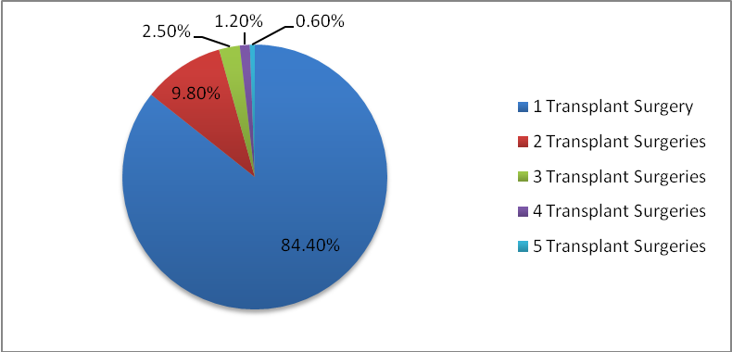

Analysis of the Surveys
The participants were instructed to fill out a series of questionnaires; the first one was geared toward evaluating individuals’ basic psychological needs for exercise. This survey measured the participants’ responses in provision of their sense of competence, autonomy and relatedness with respect to physical activity. The subcategory competence refers to the need to experience oneself as competent in controlling the exercise environment, as well as reliably foresee outcomes. Autonomy is characterized by the need to actively participate in determining one’s own physical activity behaviour, which results in experiencing one’s actions as a result of decisions made without external inferences. Relatedness refers to the need to be related to and care for others in the exercise context. According to Ryan and Deci (2000), these three psychological needs are what motivate the self to initiate behaviours and are essential for psychological health and the well-being of an individual. Figure 4 describes the mean response in each of these categories on a six point scale.

Figure 4. Mean Scores on Basic Psychological Needs for Exercise
Figure 5 demonstrated how the participants differed in these categories in terms of the degree of emotional distress they felt upon learning that they needed a transplant.
Figure 5. Mean Scores on Basic Psychological Needs for Exercise Related to Level of Emotional Distress
According to figure 5, participants that experienced more emotional distress upon learning they needed a transplant reported slightly higher levels of competence and relatedness and lower levels of autonomy for physical activity; however the data for none of these subcategories are considered statistically significant.
The subsequent questionnaire assessed motivation for leisure time physical activity. It included 5 types of motivation which consisted of amotivation, external regulation, introjected regulation, identified regulation, and intrinsic motivation. Amotivation is defined as an individual’s inability or unwillingness to participate in normal social situations. External regulation for motivation is characterized by motivation that comes from outside of the learner in the form of tangible rewards or punishments such as competition, grades, or promotions, for example. Introjected regulation is referred to as complying with external motivators without accepting it as your own; these include behaviours that are generally performed to avoid humiliation, guilt, fear, or anxiety. Identified regulation for motivation is described as acting to express one’s values and uphold one’s self investments and intrinsic motivation is when people engage in an activities without obvious external incentives (Mullen, Markland, & Ingledew, 1997). Figure 6 represents the mean values for the each type of motivation on a 5 point scale.

Figure 6. Mean Scores on Motivation for Leisure Time Physical Activity
Figure 7 demonstrated how the different types of motivation differ with regards to the levels of emotional distress experienced.
Figure 7. Mean Scores on Motivation for Leisure Time Physical Activity Related to Level of Emotional Distress
According to figure 7, participants that experienced more emotional distress experienced higher levels of all 5 types of motivation. However, only the results for identified and introjected motivation were statistically significant.

The third questionnaire entitled the Post Traumatic Growth Inventory described subcategories involving relating to others, new possibilities, personal strength, spiritual change and appreciation for life. Relating to others is defined as a means of connecting with other people due to a commonality. The subcategory new possibilities, involves being aware of alternative options and seeking out these novel opportunities. Personal strength is described the inner strength in oneself to overcome a difficult event in a person’s life. Spiritual change is referred to as the need to explore a higher power, as well as a desire to deepen spiritual practices. Appreciation for life is defined by the realization of the importance of life after the occurrence of a traumatic event (Calhoun & Tedeschi, 1998). Figure 8 describes the mean responses on a 6 point scale.

Figure 8. Mean Scores on the Post- Traumatic Growth Inventory
Figure 9. Mean Scores on Post-Traumatic Growth Inventory Related to Level of Emotional Distress
Figure 9 demonstrates that participants who experienced more emotional distress scored higher in all aspects of post-traumatic growth. All of the subcategories except spiritual change were statistically significant.

The forth questionnaire, titled the Perceived Stress Inventory, was a mean total score of 10 items completed on a 5 point scale. This survey is used as a very brief measure of stress perceptions (Cohen, Kamarck, & Mermelstein, 1983). The mean score was calculated to be 2.84, with no differences in the experience of stress reported by individuals with more or less levels of distress.

Physical Activity & Sedentary Behaviour
Commonly reported sports included swimming, golf, tai chi, walking and cycling; with the majority of the participants engaging in these activities 3 times a week at a moderate intensity. Many participants (34%) watched 3 hours of television on weekdays (figure 12) and 4 hours (figure 13) on the weekend (25.2%). Individuals engaged in an average of 89 minutes of daily total lifestyle physical activity, which includes commuting, leisure, household and work activities (figure 14).

Figure 10. Percentage of individuals indicating the number of hours of television viewing on weekdays
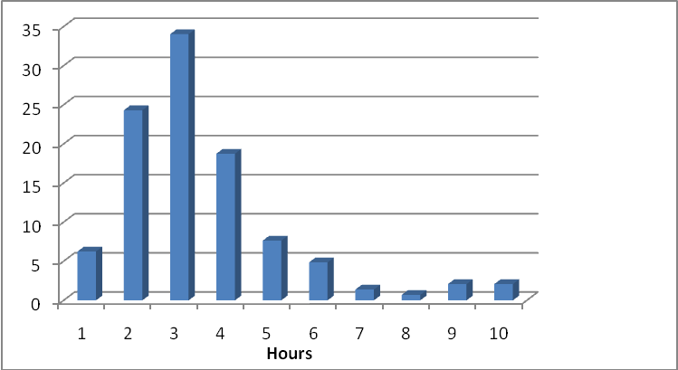

Figure 11. Percentage of individuals indicating the number of hours of television viewing on weekends
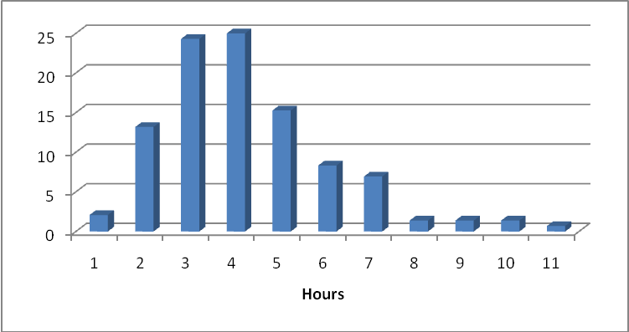

Figure 12. Physical Activity – Average Minutes per Day
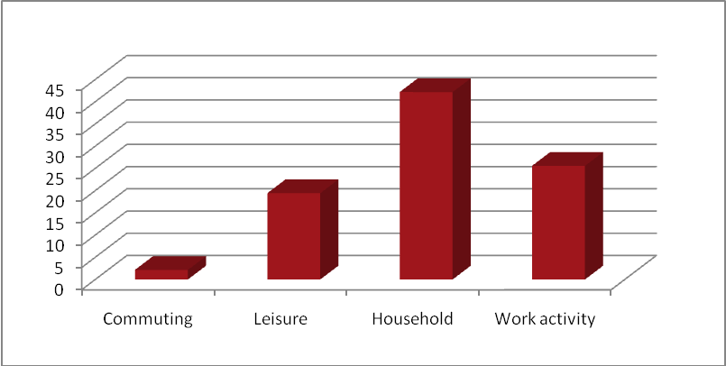

Summary and Implications
This study sought to increase the understanding of a relatively understudied concept of positive psychological growth in a population of transplant recipients. The mean scores on the measures used in this study were similar to those of other healthy adult and chronic illness populations. The findings concluded that, independent of distress levels, transplant recipients experience positive psychological growth (PTG). The results of this study also indicate that transplant recipients engage in a variety of physical activities and sedentary behaviours. It is now important to examine the associations among these variables to determine how to enhance PTG in this population, and what mental and physical health outcomes are experienced as a result of PTG. Based on theoretical perspectives, we suggest that the basic psychological needs are associated with different motives for physical activity, which are in turn linked to greater health behaviour. Increases in health behaviour, such as physical activity as studied in the current study, would then be associated with psychological growth, reduced distress, and a host of other quality of life indicators. We will then focus on developing interventions to help foster the determinants of PTG in order to help enhance health outcomes.

Acknowledgements
We would like to thank the participants of this study for taking the time to share their experiences with us. We would also like to thank all coordinators and individuals who helped pass on the word about this study. Finally, this study was funded by a McGill University Social Science and Humanities Research Grant.

References
Calhoun, L. G., & Tedeschi, R. G. (1998). Posttraumatic growth: Positive change in the aftermath of crisis. Mahwah: Lawrence Erbaum Associates.
Cohen, S., Kamarck, T., & Mermelstein, R. (1983 ). A global measure of perceived stress. Journal of Health and Social Behavior, 24, 385-396.
Mullen, E., Markland, D., & Ingledew, D. (1997). A graded conceptualization of self-determination in the regulation of exercise behavior: Development of a measure using confirmatory factor analysis procedures Personality & Individual Differences, 23, 745-752.
Sabiston, C. M., McDonough, M. H., & Crocker, P. R. E. (2007). Psycho-social experiences of breast cancer survivors involved in a dragon boat program: Exploring links to positive psychological growth. Journal of Sport & Exercise Psychology, 29, 419-438.
Wrosch, C., Scheier, M., Miller, G., Schulz, R., & Carver, C. (2003). Adaptive Self-Regulation of Unattainable Goals: Goal Disengagement, Goal Reengagement, and Subjective Well-Being Personality and Social Psychology Bulletin, 29, 1494-1508.

